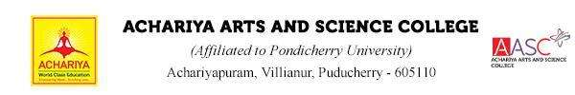
Department of Computer Science

DEPARTMENT ACTIVITIES 2022-23
ACTIVITY 1: FEST X 2k23

Name of Event : FEST X 2k23
Date of Event : 21.03.2023
Time : 9.30 am
No. of persons attended : 250
Event Venue : Achariya Arts & Science College
Event Type : Intra collegiate Event
No. of Activities : 7
Coordinator : Mrs.M.Yasothapriya
Convenor : I.Hepzi JeyaPushparani

The Department of Computer Science at Achariya Arts and Science College hosted an exciting event on Tuesday, March 21st, called "FEST X 2K23." The event aimed to create a radical and redemption aura for the students at the college. The event was a huge success with 250 participants showing up.
The morning session of the event featured a variety of activities, including an anime quiz, connection, technical quiz, treasure hunt, murder mystery, paper presentation, and Maathi Yosi. The participants were excited to participate in these events and showcase their skills. The atmosphere was buzzing with excitement as students engaged in friendly competition and tried to outdo each other.
After the successful completion of the morning activities, the valedictory session was conducted in the afternoon. The winners of the various events were announced, and prizes were distributed to the deserving participants. The winners were ecstatic to receive their awards, and their joy added to the positive energy of the event.
To conclude the event on a high note, the Department of Computer Science organized an exclusive music concert. The concert was a great way to bring everyone together and celebrate the success of the event. The participants enjoyed the music to their heart's content.
Overall, FEST X 2K23 was a memorable event that brought the students of Achariya Arts and Science College together in a fun and engaging way. The Department of Computer Science plans to organize similar events in the future to continue promoting a sense of community and encourage the students to showcase their talents.
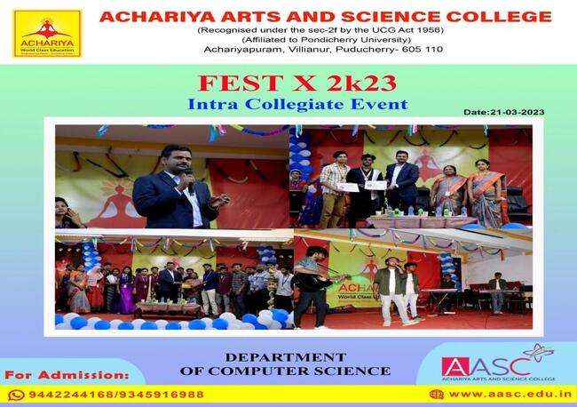
ACTIVITY 2: LOGICAL TECH GAME 2K23
Department of Computer Science organized “LOGICAL TECH GAME 2K23" Students Forum for BCA First Year Students on 23.03.2023 (Thursday) various events were conducted simultaneously.
Appreciation to all the Students who co-ordinated flawlessly and brought laurels by exposing various talents to our Department.
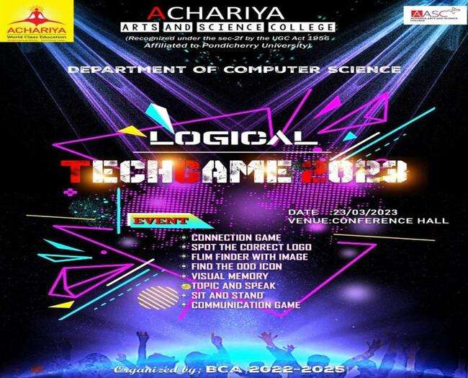

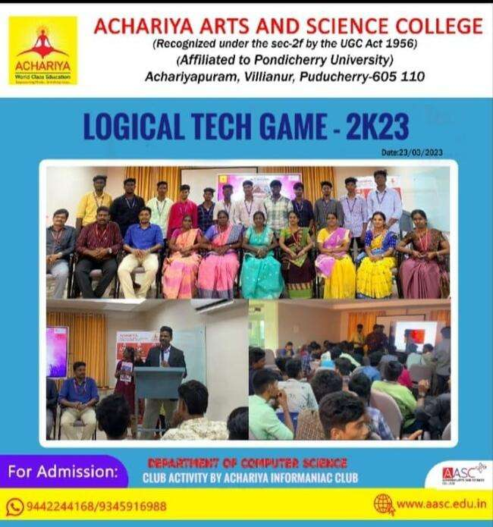

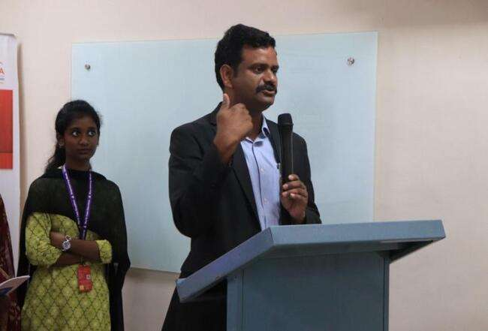

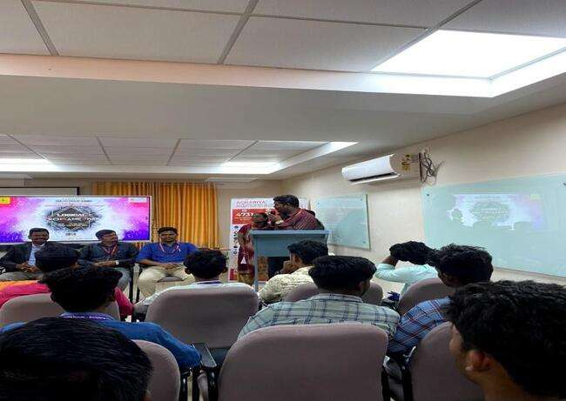
ACTIVITY 3: WEB DESIGNING WORKSHOP
Department of Computer Science organized " WEB DESIGNING" WORKSHOP for 12 GRADE Students on 06.05.2023 (Saturday).
The Students gained valuable insights into the Web Designing knowledge , and have had the opportunity to apply what they have learned through the hands-on exercises.
EVENT CONVENTOR: Mrs.I. Hepzi Jeya Pushparani
EVENT CO-ORDINATORS: Mr.R.Bharathidasan, Ms.M.Nishanthi

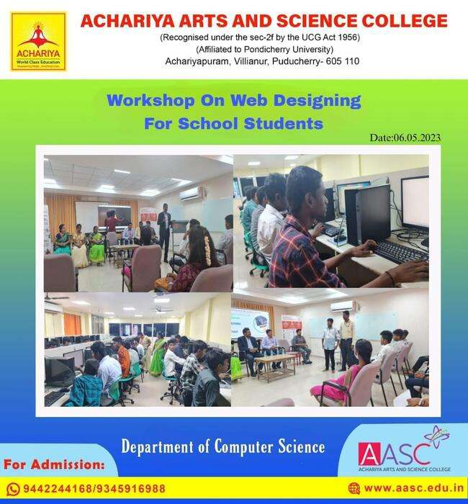

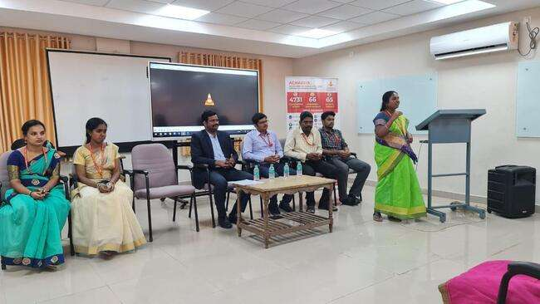
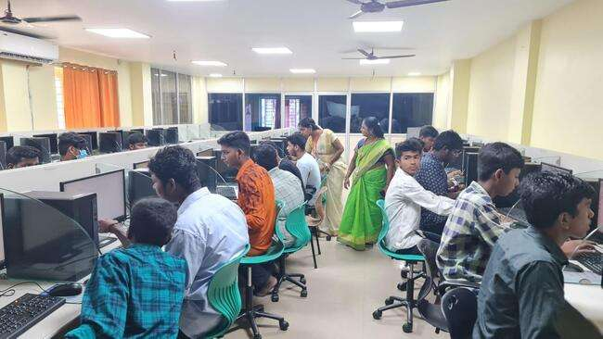
ACTIVITY 4: WORKSHOP ON FULL STACK DEVELOPMENT
Department of Computer Science organized National Workshop on “Full Stack Development” on 15th April 2023.Master of ceremony hosted by Miss.Varanlakshmi and Miss.Jayasri from ll - B.Sc Computer Science.The inaugural address was delivered by Mrs. I.Hepzi Jeya Pushparani, Head and Assistant Professor, Department of Computer Science. Presidential address was delivered by the respected principal sir Dr. V. Shanmugaraju during the event. Main Objective of this workshop is to provide the fundamental knowledge of Angular Framework and JAS with hands on practice. Around 80 students of various colleges from Puducherry and Tamilnadu were actively participated in the workshop. Expert Mr. Hemachandru Delivery Module Lead,Mphasis Technology, Chennai , explained the process and the key factor involved in the Full Stack Development through his Presentation. Students showed keen interest in the workshop and have gained the knowlege. Then the session was ended with vote of thanks was delivered by Mrs.P.Kalaiselvi, Assistant Professor, Department of Computer Science.
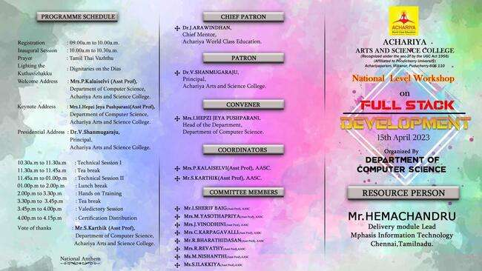
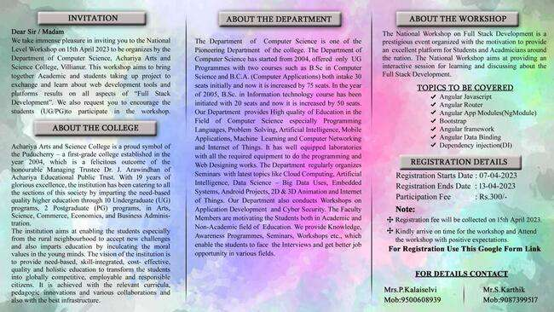

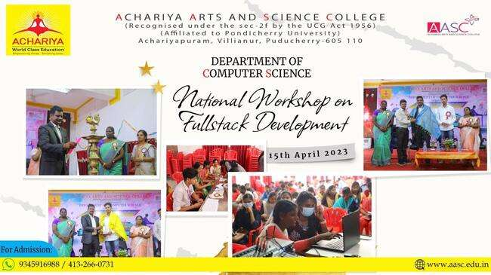

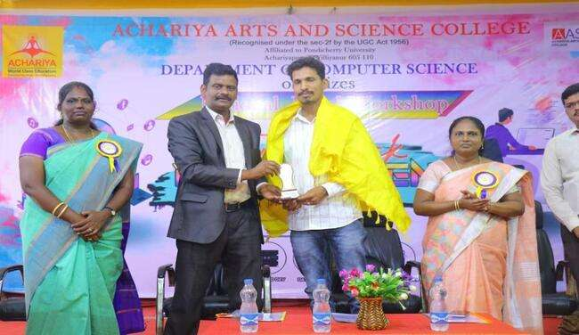
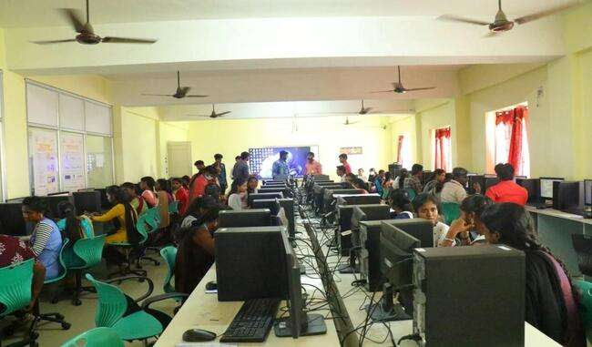

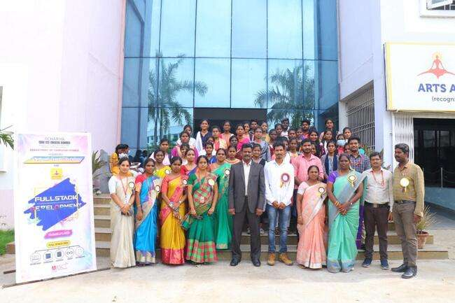

DEPARTMENT OF COMPUTER SCIENCE
ACTIVITIES 2022-23 – STUDENT FORUM
Name of Club : Achariya Info Maniac club
Name of Event : TECHNO FIESTA-2K23
Date of Event : 31.03.2023
Session : Afternoon
No. of persons attended : 41
Event Venue : Conference Hall, Achariya Arts & Science College.
Event Type : Intra Departmental Event
Coordinator : Ms.M.Nishanthi
Convenor : Mrs.I.Hepzi Jeya Pushparani
Objective of Event : To provide platform for students to showcase their skills.
Outcome of Event : Students showcased their innovative ideas and engaged in friendly
Competition and tried to outdo each other.
Event Summary
The master of ceremony was hosted by Ms.Karthiga, I-BSC.Cs and the inaugural address was delivered by Mrs.I.Hepzi Jeya Pushparani, Assistant Professor & Head. Special address was delivered by the respected Principal Dr.V.Shanmugaraju during the event followed by various interactive sessions, finally vote of thanks delivered by Mr.S.Karthik, Assistant Professor.
The session of the event featured a variety of activities, including a Spot the correction in logo, Cine quiz, Connection, Technical quiz, Visual memory and Communication game. The participants were excited to participate in these events and showcase their skills.

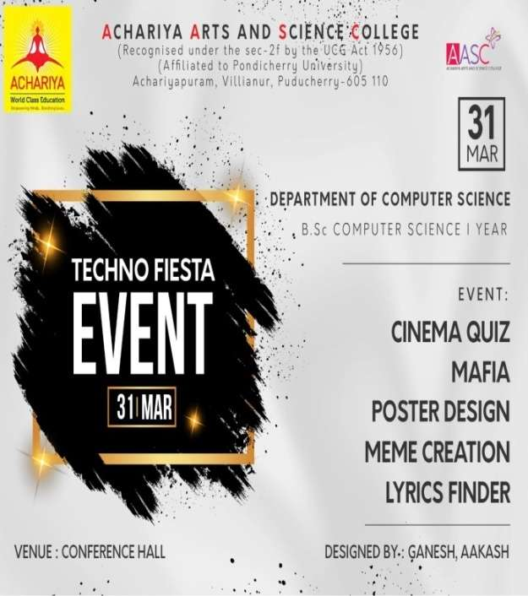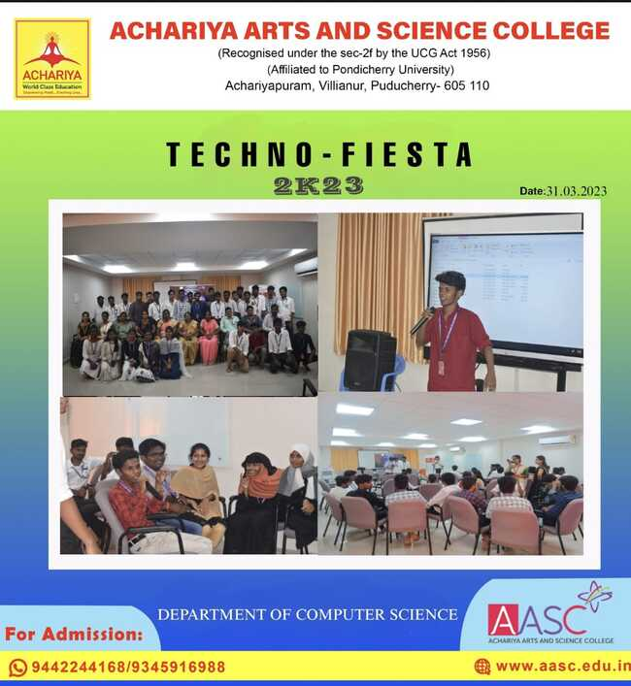

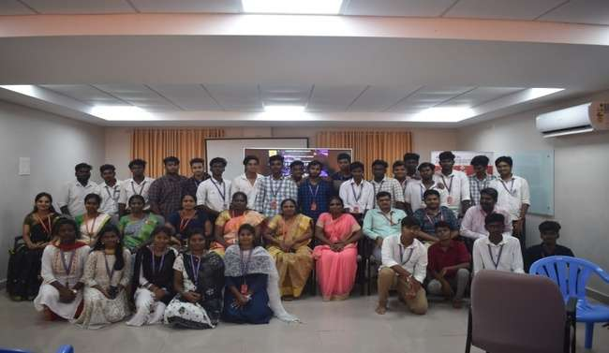
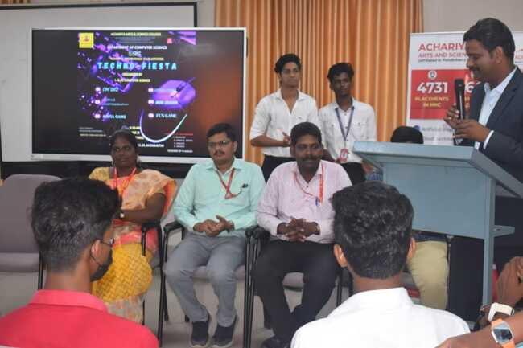
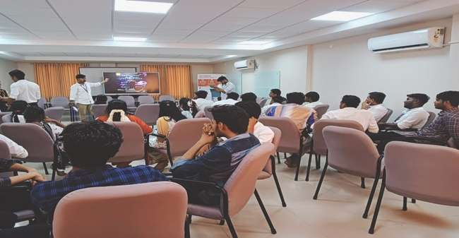

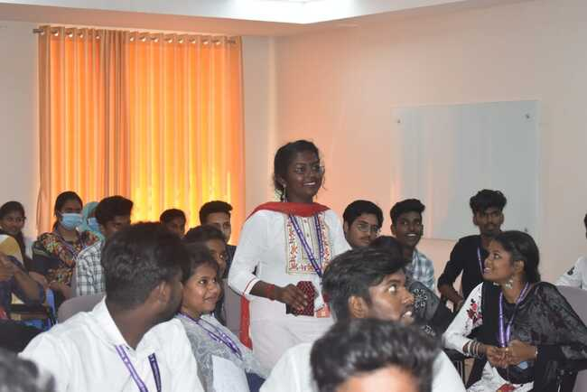

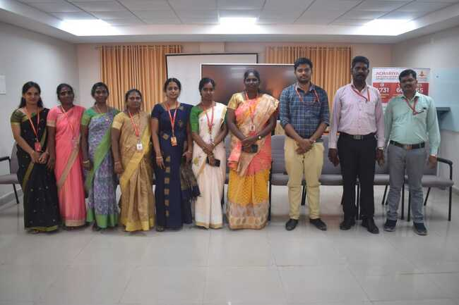

ACTIVITIES 2022-23 – STUDENT FORUM
Name of Club : Achariya Info Maniac club
Name of Event : LOGICAL TECHGAME 2023
Date of Event : 23.03.2023
Session : Afternoon
No. of persons attended : 69
Event Venue : Conference Hall, Achariya Arts & Science College.
Event Type : Intra Departmental Event
Coordinator : Mr.R.Bharathidasan & Mr.S.Karthik
Convenor : Mrs.I.Hepzi Jeya Pushparani
Objective of Event : To provide platform for students to showcase their skills.
Outcome of Event : Students showcased their innovative ideas and engaged in friendly
competition and tried to outdo each other.
Event Summary
The master of ceremony was hosted by Mrs.P.Kalaiselvi, Assistant Professor & Mr.R.Bharathidasan, Assistant Professor and the inaugural address was delivered by Mrs.I.Hepzi Jeya Pushparani, Assistant Professor & Head. Special address was delivered by the respected Principal Dr.V.Shanmugaraju during the event followed by various interactive sessions, finally vote of thanks delivered by Mr.S.Karthik, Assistant Professor.
The session of the event featured a variety of activities, including a Spot the correction in logo, Cine quiz, Connection, Technical quiz, Visual memory and Communication game. The participants were excited to participate in these events and showcase their skills.
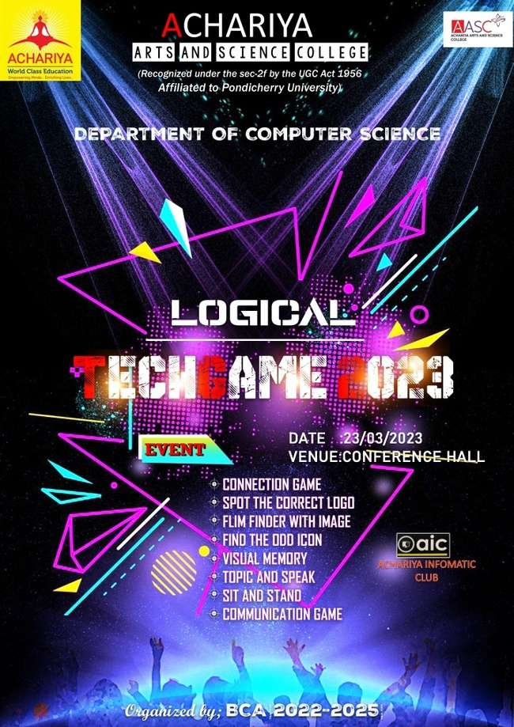

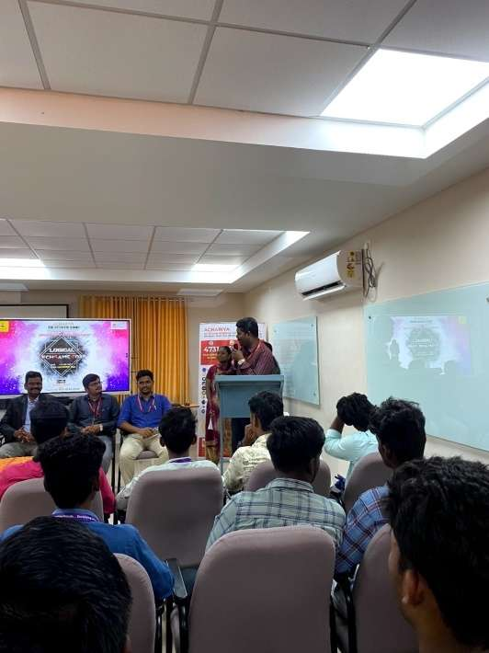
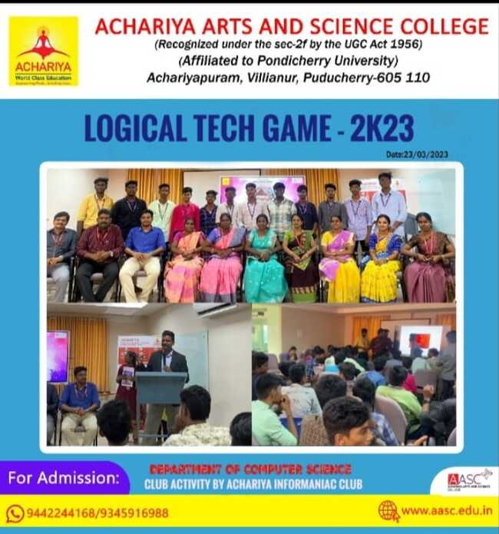

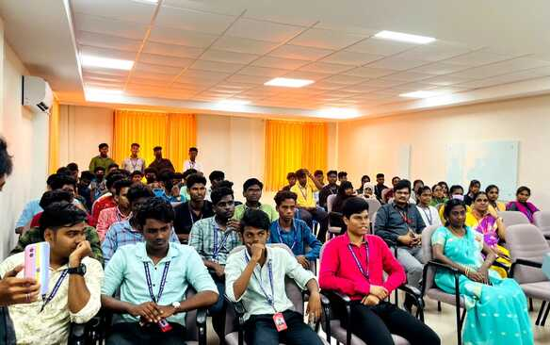

Department of Computer Science
TECHWAVES
The intra department level technical event “ TECHWAVES” was organized by computer science department under Student forum and Achariya Info maniac club in conference hall on 8th September 2023, in presence of the Principal Dr . V. Shanmugaraju sir and the head of the department & Assistant Professor Mrs. Hepsi jeya Pushparani and teaching staffs of the department. The event was led and executed successfully under the guidance of Assistant Professor Mrs.C. Karpagavalli through the students of II Year B.Sc., Information Technology Students. . The participants of the event was the students of I year B.C.A
The event was a part of various Technical and social events organized under club activities, every semester with objective to provide platform for students to showcase their talents with competitive spirit. The master of ceremony was hosted by Miss Revathy II Year, The inaugural address was delivered by Mrs .I. Hepsi Jaya Pushparani, Head of the department.,Special address was delivered by the respected principal Dr.V.Shanmugaraju during the event followed by various interactive sessions “Exposition ” a paper presentation program. Our II B.Sc.,IT students Mr.J. Vigneshwaran, presented the paper namely “Unleash -IoT”, which provided insides of IoT to the listeners . “Prober ” – a Random quiz event conducted by Mr. Naveen sathish team which act as a brain teaser to the audience. “Connecxion”-a technical connexion quiz event conducted by Mr. Jegannath team which all the participants enjoyed a lot by answering it enthusiastically.
The session geared up with a fun events “Picture Puzzle” and “Chat-Riddler ” conducted by Mr.Thirumalaiselvan Team and Mr. Kathargows Team respectively. These events took the audience to very fun filled world. Finally the winners of all the competitive events were announced and Prizes were distributed. The team of student forum and Achariya Infomaniac club feels proud to organize such a successful event and would like to convey thanks to beloved MD Dr.J. Arwindhan , respected principal sir and management, media support for their timely advice and co -operation for organizing the event “TECH WAVES”
Presidential address by Principal

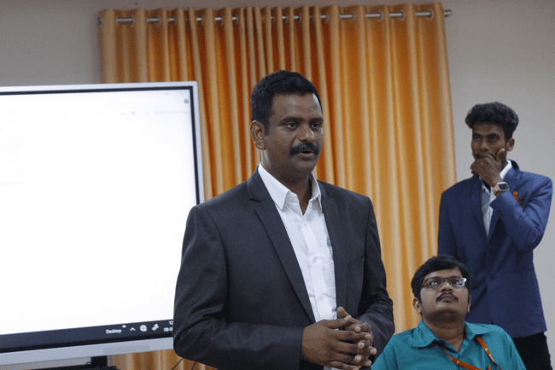
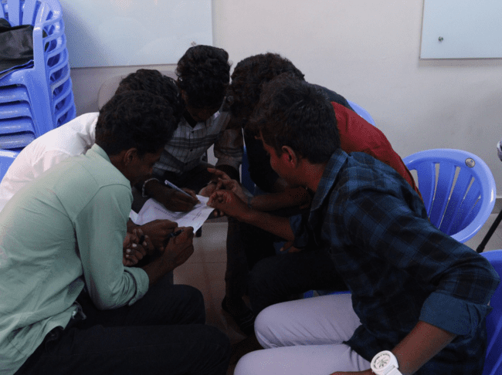

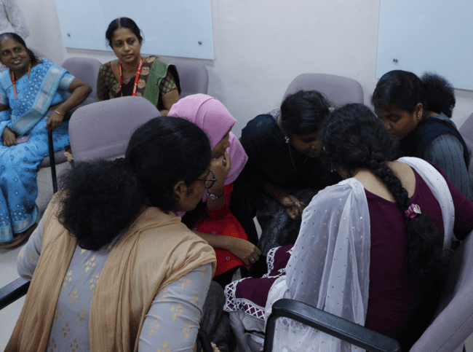

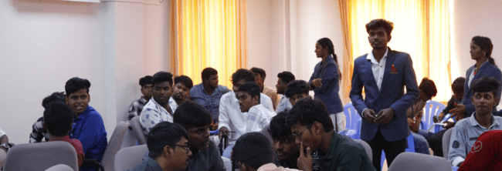

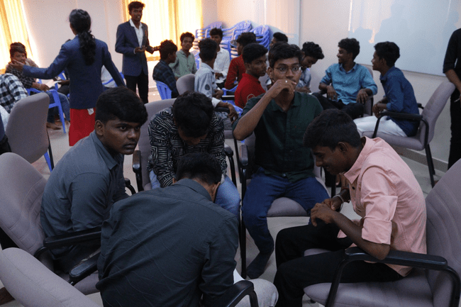

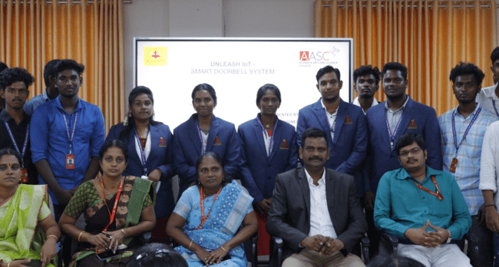

DEPARTMENT OF COMPUTER SCIENCE
Date of Event : | 20.11.2023
Name and Type of Event | GUEST LECTURE ON IT CAREER GUIDANCE IN BANKING SECTOR
Resource Person | MR.A.R.ABUL KALAM ASAD,  CONSULTANT/TECHLEAD(CORE BANKING APPLICATION,FINACLE.  SRILANKA.
Co-Ordinator | Mrs.C.Karpagavalli
No. Of Participant | 150

Objectives:
- To assist students in exploring and understanding career path in banking sector
- To facilitate interaction between students and industry professionals.
Outcomes:
- Provides improvement in communication skill, professional conduct to students.
- Provides support to students in taking clearer career goals.
Summary of the event:
The Department of Computer science organized a “Guest lecture on IT career guidance in banking sector”. The event commenced with the welcome address of Mrs.C.Karpagavalli, Assistant professor, followed by the presidential address of vice principal Dr.T.Janarthanan sir, then Mrs.Hepsi Jeya pushparani Assistant Professor & Head, extended a felicitation address.
The guest lecture featured Mr.Abul, Finacle, Srilanka, provided a road map to navigate the ever evolving professional sphere. Participants all our department students delved into the dynamic landscape of career development. The session went vary interactive, the student arouse their queries to the resource person, and He shared his valuable experience with the students. The session concluded with a vote of thanks delivered by Mr.Sherif Baig, Assistant Professor

1.Inaugration of the Guest Lecture 2.Welcome Address
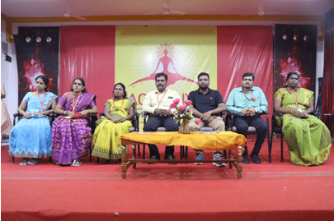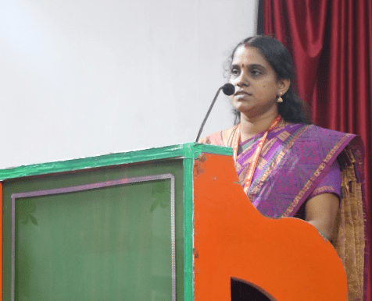
3.Honouring the Chief Guest.
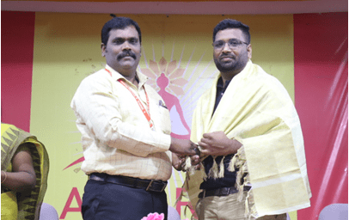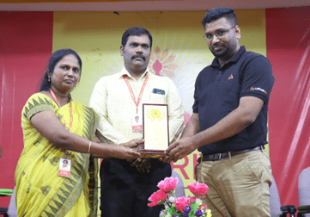
4.Lecture by chief guest.
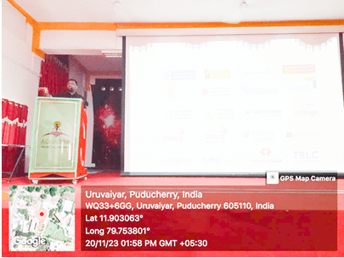
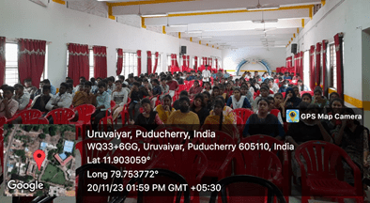

DEPARTMENT OF COMPUTER SCIENCE
Date of Event : | 4.4.2024
Name and Type of Event | GUEST LECTURE ON UI/UX DESIGN PROCESS
Resource Person | MR.U.SAKTHIVELU,  Technical Staff,  Institute of Media Arts & Graphics Effects.
Co-Ordinator | Mrs.C.Karpagavalli
No. Of Participant | 75

Objectives:
- To inspire students to think creatively and push the boundaries of traditional design practices
- To guide students in navigating their career path, develop their skills in their UI/UX design practice.

Summary of the event:
The Department of Computer science organized a “Guest lecture on UI/UX Design Process”. The event commenced with the welcome address of Mrs.C.Karpagavalli, Assistant professor, followed by the presidential address of vice principal Dr.T.Janarthanan sir, then Mrs.Hepsi Jeya pushparani Assistant Professor & Head, extended a felicitation address.
The Guest lecture featured Mr. U.Sakthivelu, Technical Staff, IMAGE- Creative Education, as the resource person. Their lecture provided crystal clear idea about the recent trends in the UI/UX design field. They shared their knowledge from their work field, providing valuable insights into current trends, techniques and challenges in UI/UX design journey. Participants, all our department students involved enthusiastically indulge in the theme and took part eagerly in the interactive session. The session concluded with a vote of thanks delivered by Mr.Maheshwar , II B.SC., IT.

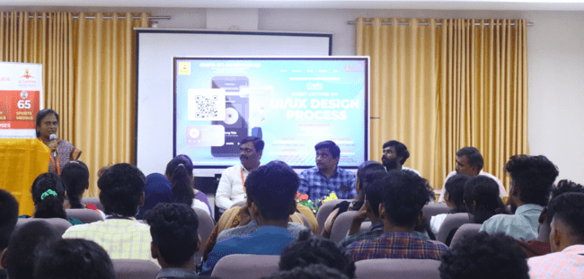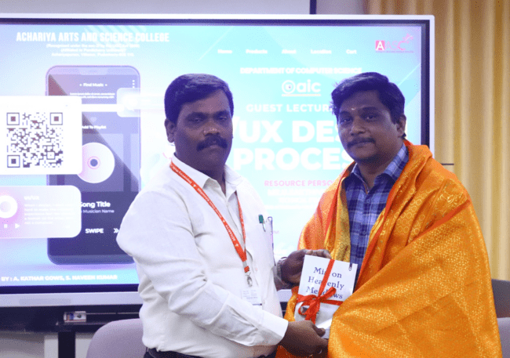

3. Presidential Address by Principal 4.Lecture by Resource Person
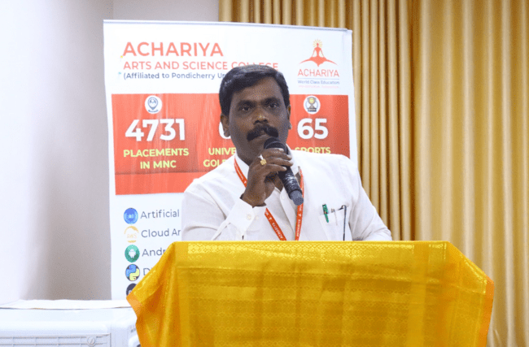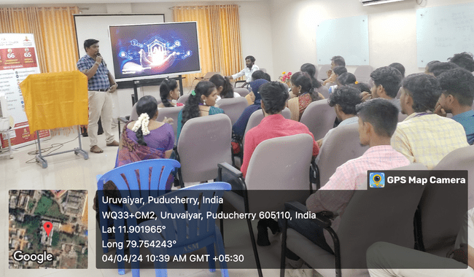

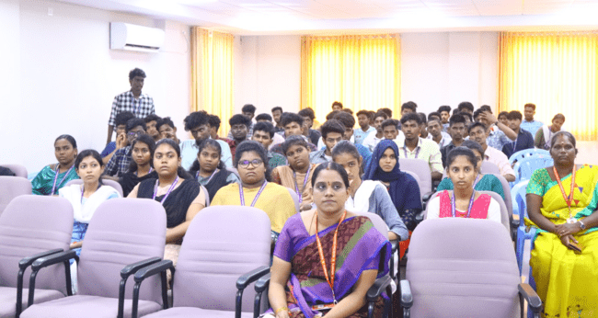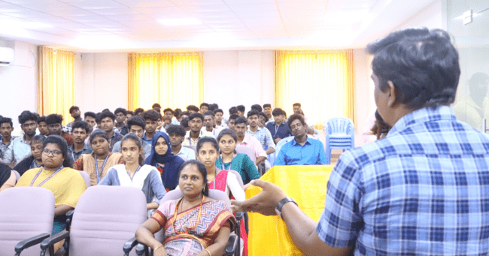

EVENT NAME: Guest Lecture on Artificial Intelligence
DATE HELD ON: 19.08.24
SESSION: Forenoon
NO.OF PARTICIPANTS: 50
EVENT VENUE: AASC Conference
RESOURCE PERSON: Ms. Janani Srinivasan
List of topics covered in this session:
  - Introduction of AI and Perspective
  - Machine Learning Importance
  - Natural Language Processing in day to day life
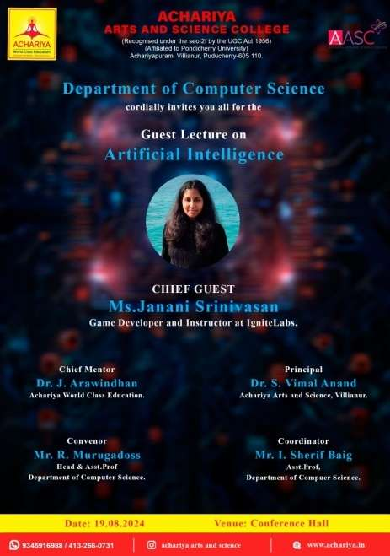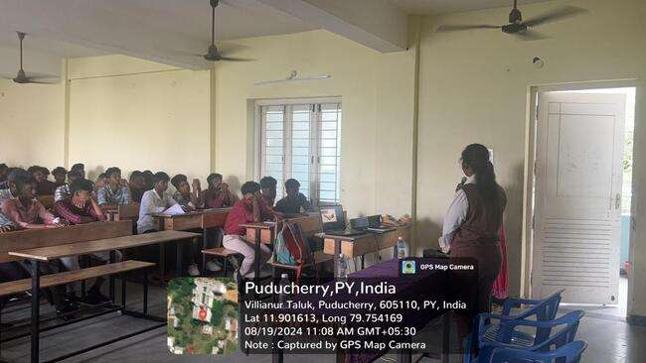

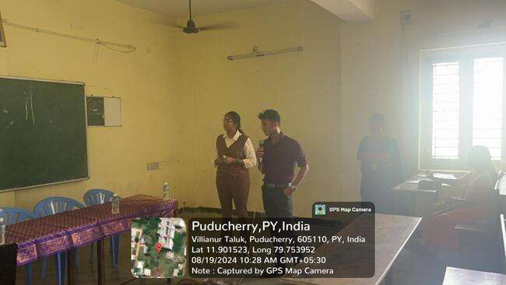

DEPARTMENT OF COMPUTER SCEINCE
DEPARTMENT ACTIVITIES 2024-25
Name of Event : NATIONAL WORKSHOP ON AWS (Amazon Web
Services)
Date of Event : 25.10.2024
No. of participants: 77
Event Venue: AASC Conference Hall
Event Summary
With Joy and Happiness, the Department of Computer Science organized a National Workshop on Amazon Web Services (AWS) on October 25, 2024 at AASC conference hall.
The event began with welcome address by Ms. V. Krishna Priya of (I-BCA) Dr.S.Vimal Anand sir Principal accepted as the guest of honor. Presidential Address delivered by Dr. T. Janarthanan , Vice Principal & Head Department of English, Mrs. K. Vijayalakshmi, a DevOps Engineer at Sivisoft Solutions Pvt. Ltd., invited as the resource person of the workshop. Mr.M.Murugadoss Head department of computer science and Ms.M.Nishanthi, Assistant Professor, department of computer science coordinated the event. All the facility members of computer science attended the event.
Morning Session
Mrs. Vijayalakshmi provided a comprehensive introduction to AWS, covering key aspects such as Compute, Storage, Security, and Identity Compliance. Participants from various college gained insights into Robotic Process Automation (RPA).
Afternoon Session
The afternoon session a hands-on workshop focusing on practical topics, including:
- EC2: Creation of virtual machines (VMs) on different operating systems and connecting them using Putty.
- S3: Amazon Simple Storage Service.
- IAM: Creating IAM users, roles, groups, and attaching policies.

These sessions have enabled participants to apply their knowledge in real-world scenarios. Students from various colleges enthusiastically come forward to attend the workshop and gained practical knowledge about the given topic. The colleges, include Saradha Gangadharan College, St. Joseph’s College, Immaculate College for Women, Idhaya College of Arts & Science for Women, and Achariya College of Engineering and Technology (ACET).
The active engagement of the participants highlighted the event’s success in fostering a deeper understanding of Amazon Web Services. In the concluding session, Mrs.Vijayalakshmi distributed participation certificates, adding a special touch to the occasion. The event concluded with a vote of thanks delivered by Ms. G. Banu Thrishya of (II-B.Sc. Computer Science).

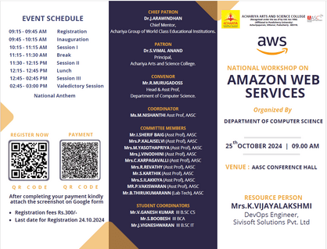

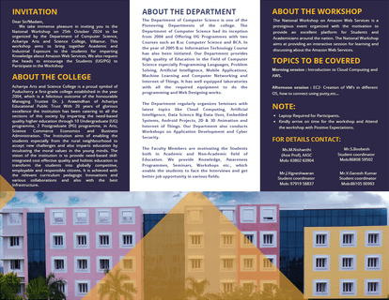

REGISTERATION:
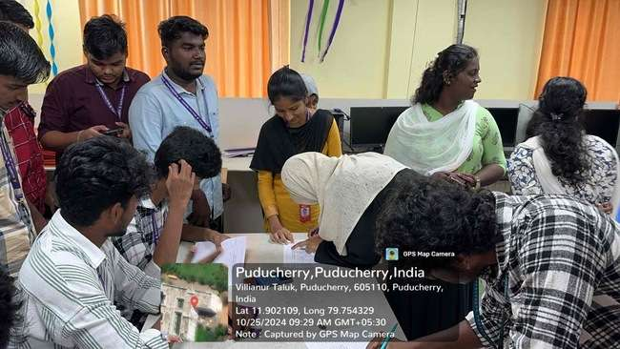

EVENT INAGURATION:

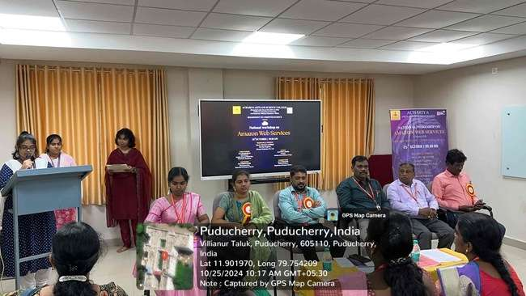

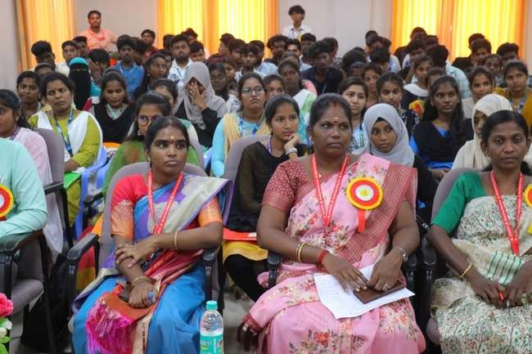

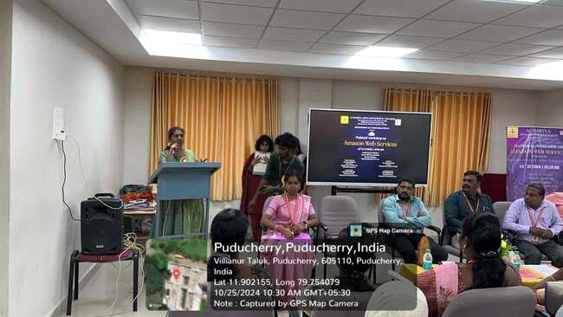

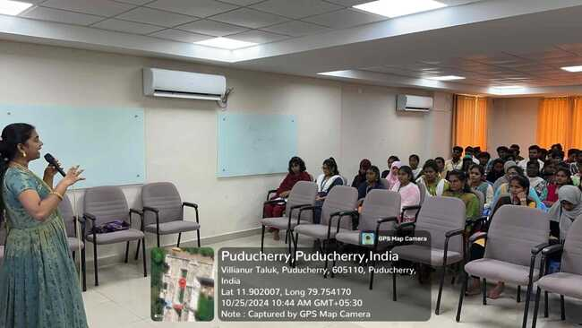

CERTIFICATES DISTRIBUTION:

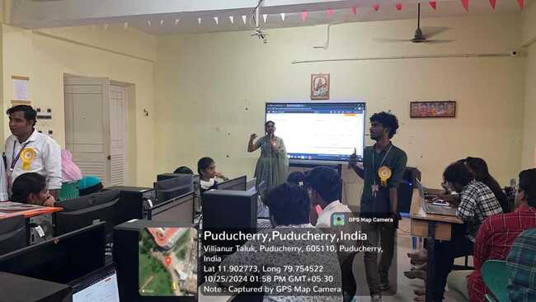
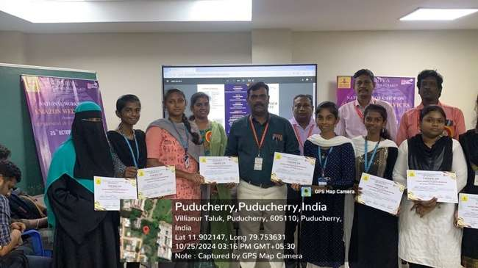

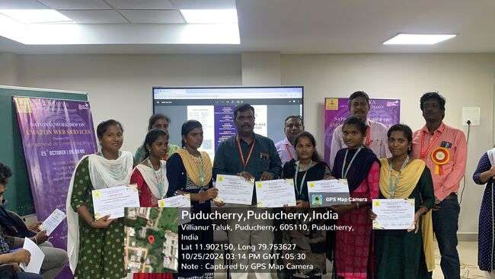

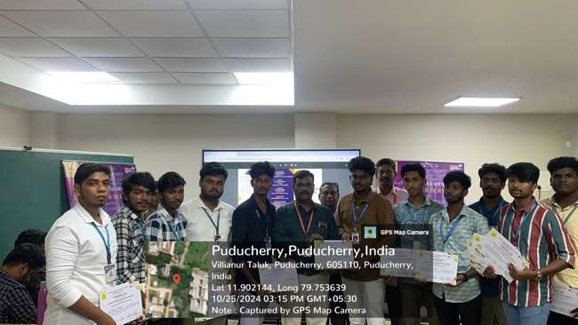

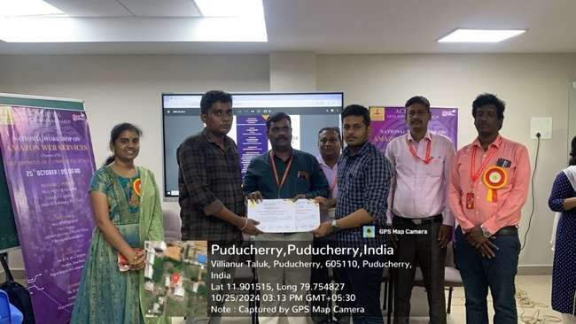

VOTE OF THANKS:

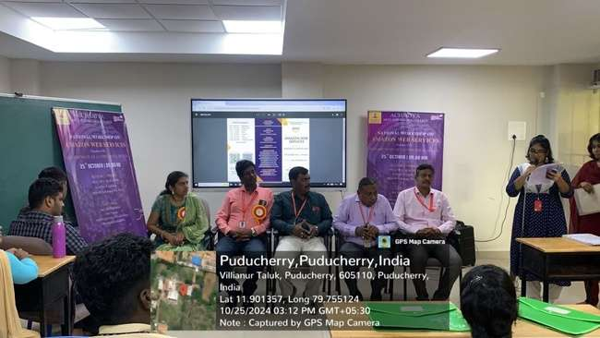
DEPARTMENT OF COMPUTER SCIENCE
SUMMARY
Name of Event : National Workshop
Date : 10.11.23
No. of persons attended : 76
Event Venue : Achariya Arts & Science College, Conference Hall
Event Type : Workshop
Total No. of students Registered : 76
Resource Person : Mrs.A.Kavitha, Solution Architect, Wipro limited.
Coordinators : Mrs.M.Yasothapriya & Ms.N.Nishanthi

Event Summary
Department of Computer Science organized a National Workshop on Robotics Process Automation (RPA) on November 10, 2023. The event commenced with the inaugural session, and Mrs. M. Yasothapriya, Assistant Professor, delivered the welcome address. This was succeeded by the Presidential Address from Principal Dr.V.Shanmugaraju, Sir. Subsequently, Mrs. Hepzi Jeya Pushparani, Head, and Assistant Professor, extended a felicitation address.
The workshop featured Mrs. A. Kavitha, a solution architect at Wipro Limited, as the resource person . She conducted two insightful sessions during the event.
In Session I
Mrs. Kavitha provided a comprehensive introduction to RPA and specifically delivered into Automation in UI Path. The participants gained valuable insights into the RPA.
Session II was a hands-on workshop focusing on UI Path, allowing attendees to apply their knowledge in a practical setting.
The workshop drew enthusiastic participation from students representing various colleges, including Mailam Engineering College, Saradha Gangadharan College ,Pope John Paul College of Education, Loyola College in Chennai, Idhaya College of Arts & Science for Women and Sri Manakula Vinayakar Engineering College along with our college students. Their active engagement showcased the success of the event in fostering a deep understanding of Robotics Process Automation.

In the culmination of the event, the esteemed chief guest, Mrs.A.Kavitha mam, graciously distributed participation certificates to all those in attendance, adding a touch of honor to the occasion. The session concluded with a vote of thanks delivered by Ms.M.Nishanthi , Assistant Professor.
NATIONAL WORKSHOP REPORT
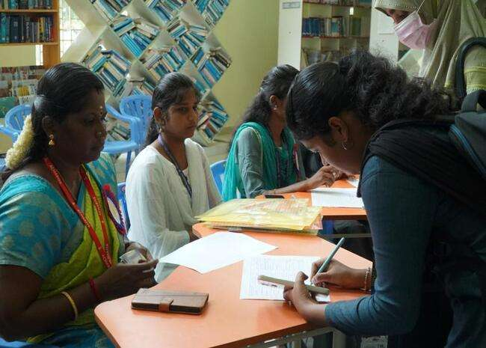

Students Registration

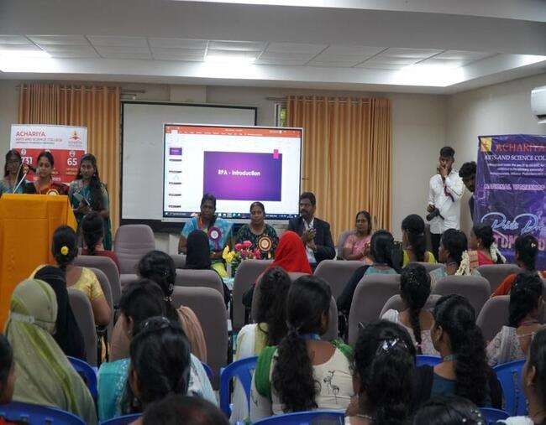

Welcome Address

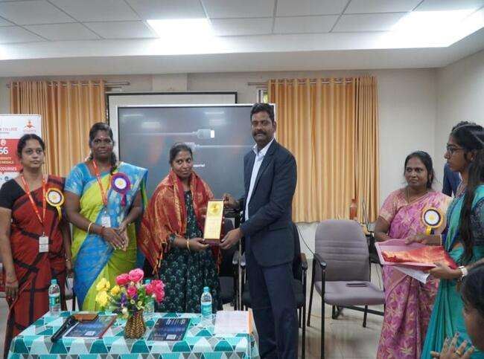

Honoring Chief Guest

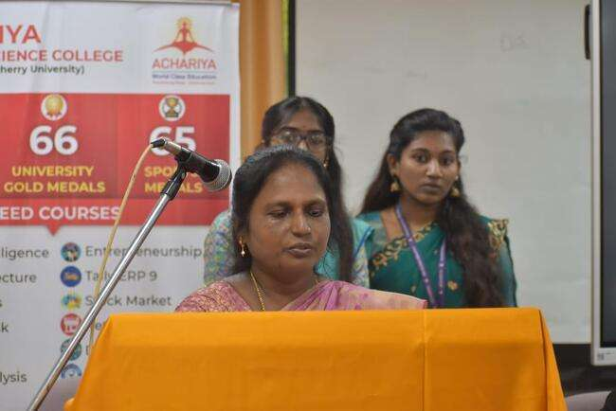

Convener Address

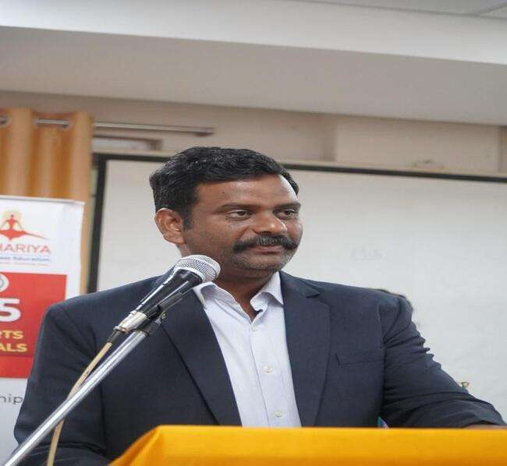

Principal Address
SESSION I:

- RPA Introduction
- Automation using AI Path
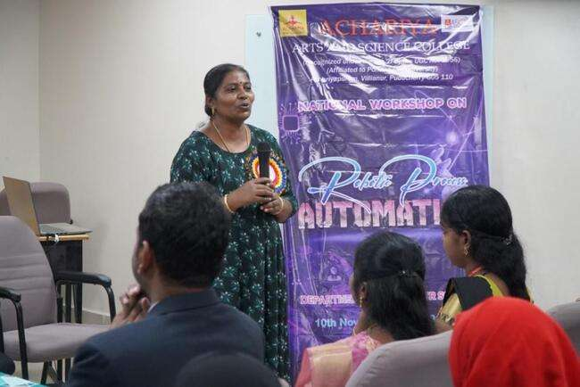

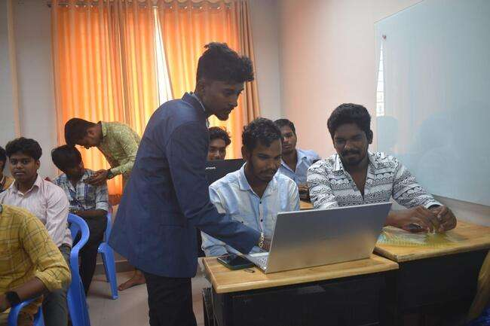

SESSION II: UI Path Hands-On Training
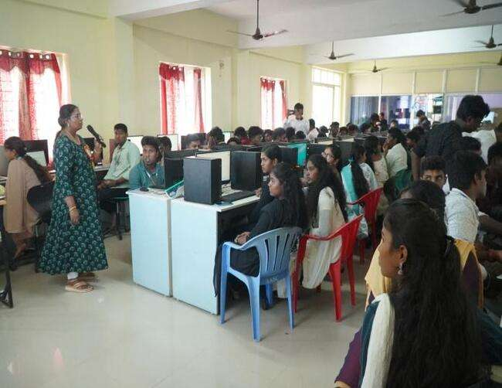

DISTRIBUTION OF CERTIFICATES
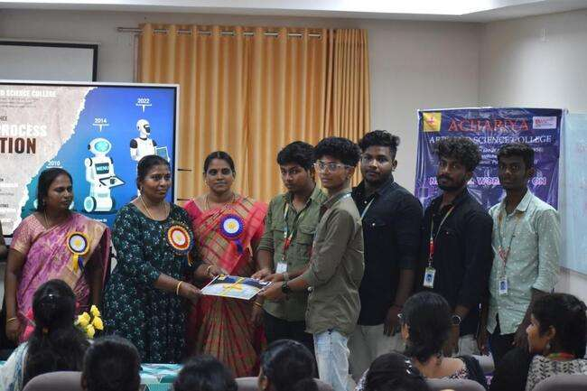

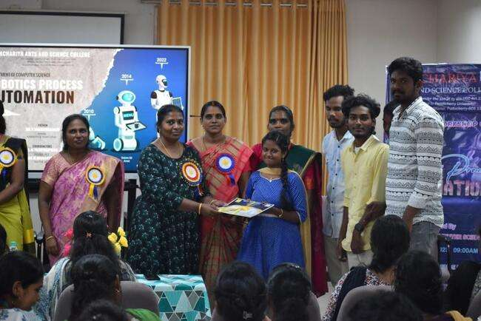

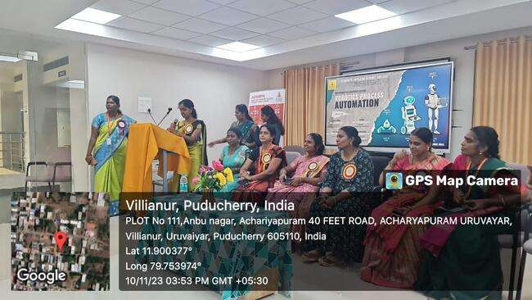

Vote of Thanks

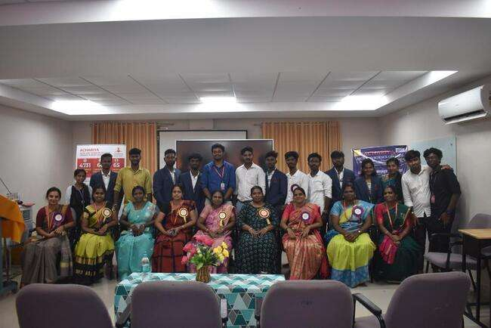

SS

